Ryan Miller

To get started, navigate to the ~/Projects directory where your downloaded TarDocs.tar archive file should be.

1. Extract the TarDocs.tar archive file into the current directory (~/Projects). Afterwards, list the directory's contents with ls to verify that you have extracted the archive properly.

* Note that because we want to preserve the directory structure of our archive, we do not have to specify a target directory to extract to.

tar xvf TarDocs.tar



* Note that when your run ls you should see a new ~/Projects/TarDocs directory with 5 new subdirectories under TarDocs/

1. Verify that there is a Java subdirectory in the TarDocs/Documents folder by running: ls -l ~/Projects/TarDocs/Documents/.

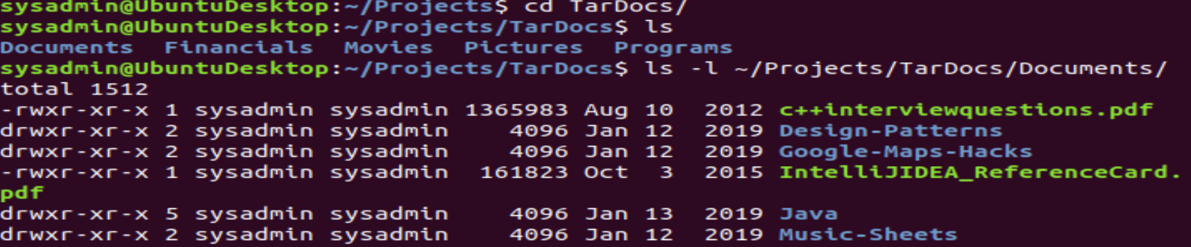

1. Next, create a tar archive called Javaless_Docs.tar that excludes the Java directory from the newly extracted TarDocs/Document/ directory.

<https://askubuntu.com/questions/811081/how-do-i-use-tar-to-exclude-all-files-of-a-certain-directory>



* If you've executed this command properly, you should have a Javaless_Docs.tar archive in the ~/Projects folder.

1. Verify that this new Javaless_Docs.tar archive does not contain the Java subdirectory by using tar to list the contents of Javaless_Docs.tar and then piping grep to search for Java.

tar -tvf Javaless_Docs.tar | grep Java

1. **Bonus:** Create an incremental archive called logs_backup.tar.gz that contains only changed files by examining the snapshot.file for the /var/log directory. You will need sudo for this command.

### **cron: Create, manage and automate various cron jobs**

In response to a ransomware attack, you have been tasked with creating an archival and backup scheme to mitigate against CryptoLocker malware. This attack would encrypt the entire server’s hard disk and it can only be unlocked using a 256bit digital key after payment using bitcoin.

* For this task, you'll need to create an archiving cron job using the following specifications:  
  + This cronjob should create an archive of the following file: /var/log/auth.log
  + The filename and location of the archive should be: /auth_backup.tgz
  + The archiving process should be scheduled to run every Wednesday at 6AM
  + Use the correct archiving zip option to compress the archive using gzip
* To get started with creating cronjobs, run the command, crontab -e. Also, make sure that your cronjob line includes the following:  
  + The schedule (minute, hour, etc.) in cron format  
    - Don't forget the tremendously helpful site: [crontab.guru](https://crontab.guru/)
  + After the schedule, you need an archive (tar) command with three options, followed by the path to save the archive to, and the path of the file to archive.

0 6 * * 3 tar -cvzf /auth_backup.tgz /var/log/auth.log

### **bash scripting: Write basic bash scripts**

Portions of the Gramm-Leach-Bliley Act require organizations to maintain a regular backup regimen for the safe and secure storage of financial data.

In this exercise, you'll first need to set up multiple backup directories. Each directory will be dedicating to housing text files that you will create with different kinds of system information.

* For example, the directory, freemem, will be used to store **free memory** system information files.

1. Using brace expansion, create the following four directories:  
   * ~/backups/freemem
   * ~/backups/diskuse
   * ~/backups/openlist
   * ~/backups/freedisk
2. **Note**: Remember that brace expansion uses the following format: ~/exampledirectory/{subdirectory1,subdirectory2,etc}



Now you will create a script that will execute various Linux tools to parse information about the system. Each of these tools should output results to a text file inside its respective system information directory.

* For example: cpu_usage_tool > ~/backups/cpuuse/cpu_usage.txt  
  + In the above example, the cpu_usage_tool command will output CPU usage information into a cpu_usage.txt file.

1. To get started with setting up your script up in your home directory, do the following:

* Navigate to your home directory by running: cd ~/
* After, run the command nano system.sh to open a new nano window.

**Note**: If you're unsure how to get started, we included a system.sh starter file. Use that as a guide.

1. Edit this system.sh script file so that it that does the following:  
   * Prints the amount of free memory on the system and saves it to ~/backups/freemem/free_mem.txt.
   * Prints disk usage and saves it to ~/backups/diskuse/disk_usage.txt.
   * Lists all open files and saves it to ~/backups/openlist/open_list.txt.
   * Prints file system disk space statistics and saves it to ~/backups/freedisk/free_disk.txt.
2. **Note**: For the free memory, disk usage, and free disk commands, make sure you use the -h option to make the output **human-readable**.

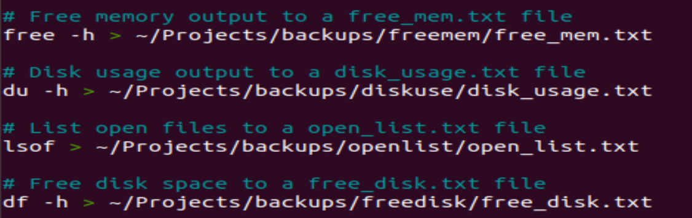

1. Save this file and make sure to change or modify the system.sh file permissions so that it is executable.  
   

You should now have an executable system.sh file within your home ~/ directory.

1. Test the script with sudo ./system.sh.  
     
    **Note**: Ignore the warning: lsof: WARNING: can't stat() fuse.gvfsd-fuse file system /run/user/1001/gvfs Output information may be incomplete. if you see it.



1. **Optional**: Confirm the script ran properly by navigating to any of subdirectories in the ~/backup/ directory and use cat <filename> to view the contents of the backup files.

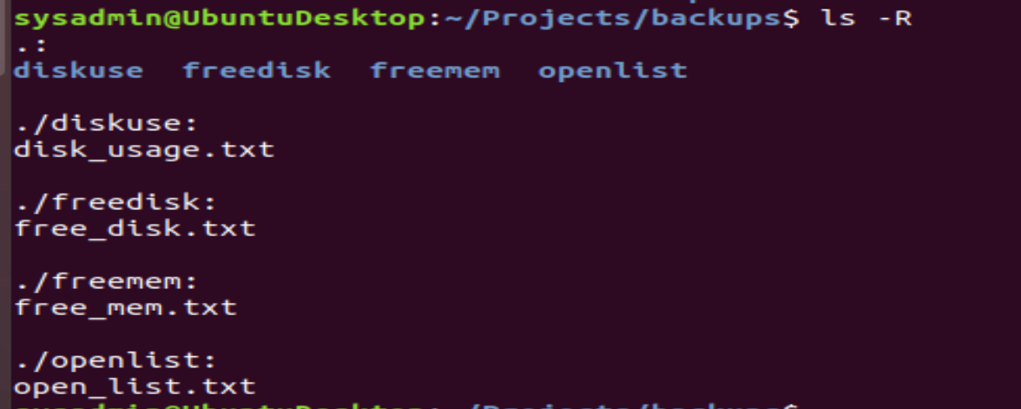

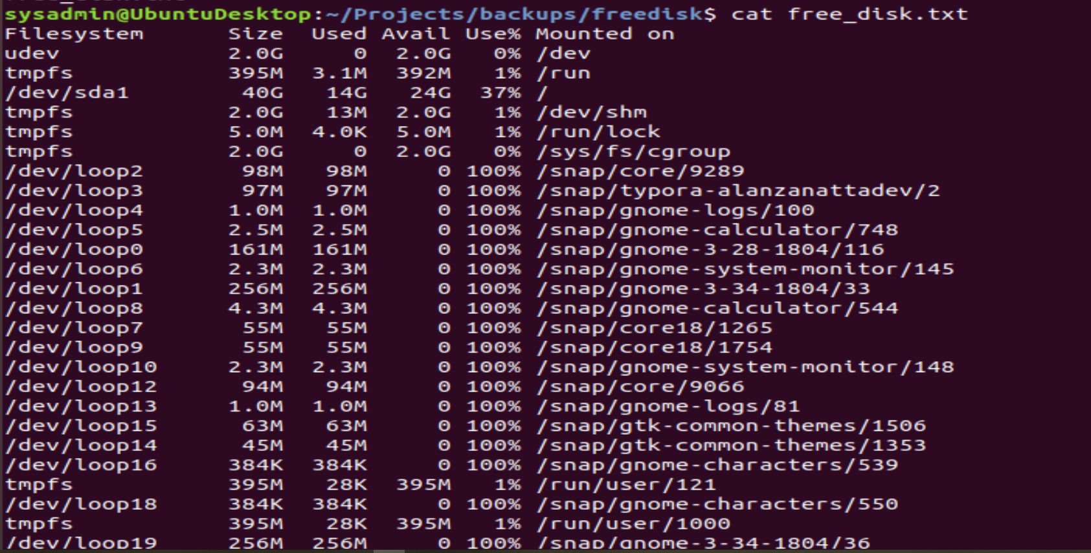

1. **Bonus**: Automate your script system.sh by adding it to the weekly system-wide cron directory.

### **journalctl: Perform various log filtering techniques**

There was a suspicious logon from a host on the network during the early morning hours when the office is closed. The Senior Security Manager tasked you with filtering through log files to determine if a system breach occurred.

Remember that journal tracks each log relative to each system boot. Also, keep in mind that you can also sort messages by **priority**, relative **boot**, and specific **units**.

1. Using journalctl, perform a log search that returns all messages, with priorities from emergency to error, since the current system boot.

Filter from priority 0 (emerg) to 3 (err)

journalctl -p err

1. Use journalctl to check the disk usage of the system journal unit since the most recent boot. You will likely have to pipe this output to less if it doesn't fit on the screen.  
   * The unit you want is systemd-journald.

sudo journalctl -u systemd-journald | less

1. Use journalctl to remove all archived journal files except the most recent 2.

sudo journalctl --vacuum-files=2

1. **Bonus**: Use journalctl to filter all log messages with priority levels between 0 and 2 and save the results to a file named Priority_High.txt in /home/student/ directory.
2. **Bonus 2**: Automate the last task by creating a cron job that runs daily in the user crontab.  
     
    **Note**: You'll need sudo to run journalctl.

### **rsyslog: Priority based log file creation**

Your organization is constantly bombarded with spam messages, a form of **social engineering** attacks. To address this, you’ve decided to implement a priority based log filtering system to monitor access to the mail daemon.

In order to get started with editing rsyslog configurations, from any directory within your terminal, run sudo nano /etc/rsyslog.d/50-default.conf to edit the rsyslog config file.

1. Configure rsyslog to record mail log message for all priorities *EXCEPT* debug to the /var/log/mail.log directory.  
   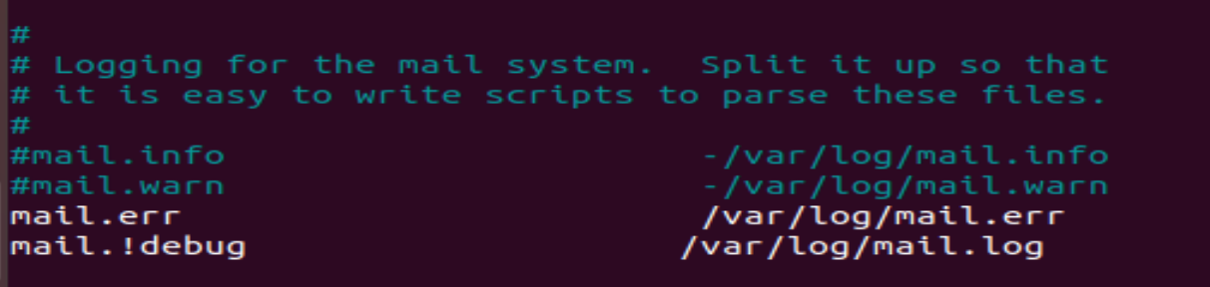
2. **Bonus**: Configure rsyslog to record boot log message for priorities *EXCEPT* info and debug to the /var/log/boot.log directory.

<https://access.redhat.com/solutions/9834>

boot.!=info /var/log/boot.log

### **logrotate: Manage log file sizes**

Because of the spam messages, you realized that the size of the log files are becoming unmanageable.

You’ve decided to implement log rotation in order to preserve log entries and keep log file sizes more manageable. You’ve also chosen to compress logs during rotation to preserve disk space and lower costs.

To get started with this exercise, run sudo nano /etc/logrotate.conf to edit the logrotate config file. You don't need to work out of any specific directory as you are using the full configuration filepath.

Don't forget to surround your rotation rules with curly braces {}.

1. Configure a log rotation scheme that backs up authentication messages to the /var/log/auth.log directory using the following settings:  
   * Rotates weekly.

weekly

* + Rotates only the most recent 7 logs.

Rotate 7

* + Does not rotate empty logs.

notifempty

* + Delays compression.

delaycompress

* + Skips error messages for missing logs, then continues to next log.

Missingok

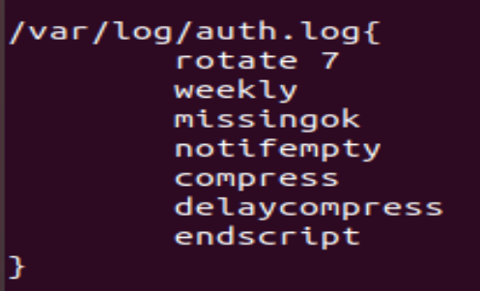

### **BONUS ACTIVITY auditd: Check for policy and file violations.**

In an effort to help mitigate against future attacks, you have decided to create an event monitoring system that specifically generates reports whenever new accounts are created or modified and when any modifications are made to authorization logs.

1. First, verify the auditd service is active using the systemctl command.
2. Run sudo nano /etc/audit/audit.conf to edit the auditd config file using the following parameters. You can run this command from anywhere using the terminal.  
   * Number of retained logs is 7
   * Maximum log file size is 35
3. Next, run sudo nano /etc/audit/rules.d/audit.rules to edit the rules for auditd and create rules that watch the following paths:  
   * For /etc/shadow, set wra for the permissions to monitor and set the keyname for this rule to hashpass_audit.
   * For /etc/passwd, set wra for the permissions to monitor and set the keyname for this rule to userpass_audit.
   * For /var/log/auth.log, set wra for the permissions to monitor and set the keyname for this rule to authlog_audit.

* Restart the auditd daemon.
* Perform a listing that reveals all existing auditd rules.  
  + **Note**: If you're unsure how to construct these rules, refer to the auditd section within the Student Guide.

1. Using sudo, produce an audit report that returns results for all user authentications.

* **Note:** You will need to log out and back in to populate the report.

1. Time to shift into hacker mode: Create a user with sudo useradd attacker then produce an audit report that lists account modifications.
2. Add another rule using auditctl that watches the /var/log/cron directory.  
   * Perform a listing that reveals changes to the auditd rules took affect